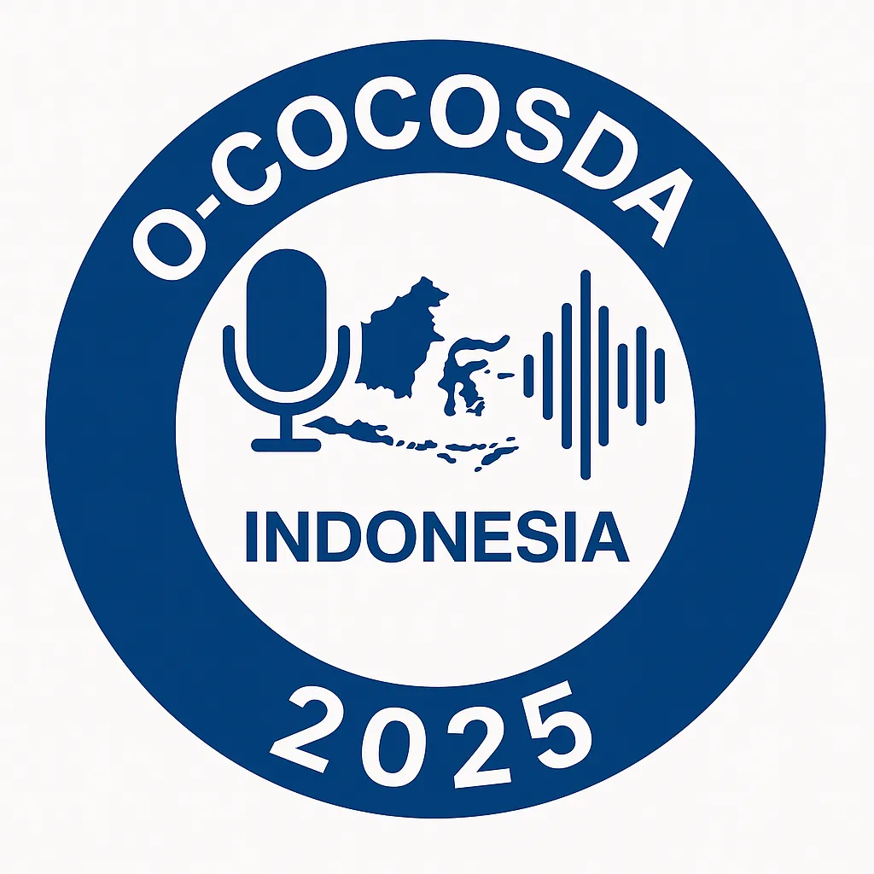 | O-COCOSDA 2025  Copyright Transfer Agreement

This Copyright Transfer Agreement is made between the Author(s) of the work described below and the Organizing Committee of the 2025 Oriental COCOSDA International Conference (O-COCOSDA 2025). By signing this agreement, the Author(s) transfer certain rights to the Organizing Committee, as specified herein.

Work Description
Paper Title: ___________________________________________
Author(s): ____________________________________________
Corresponding Author Email: ____________________________

1. Copyright Transfer
The Author(s) hereby assign to the Organizing Committee of O-COCOSDA 2025 the copyright of the above Work, including all rights to publish, reproduce, distribute, and archive the Work, in printed or electronic form, in the O-COCOSDA 2025 Proceedings.

2. Publication Venue
The Work has been accepted for publication in the O-COCOSDA 2025 Proceedings (non-IEEE).

3. Author Rights
Notwithstanding the copyright transfer, the Author(s) retain the following rights:
- To use all or part of the Work in future works of their own (such as books or collected works).
- To reproduce the Work for educational and research purposes, provided proper citation is given.
- To post the Author’s accepted manuscript (not the final published version) on personal or institutional repositories, with acknowledgment of O-COCOSDA 2025.

4. Author Warranties
The Author(s) warrant that the Work is original, does not infringe on any existing copyright, and that all necessary permissions for reproducing copyrighted material (if any) have been obtained.

5. Signatures
Authorized Signature (on behalf of all authors): _______________________
Name: _________________________________________________

